**Design Scenario:**

**I have chosen to create a modular water pump because I wanted to find a way to move water from one container to another without the use of any excess or unnecessary energy. I need to move water in this way so I can run my yet to be completed hydroelectric power generator seamlessly.**

**Design Brief:**

**I am going to design and create a modular, pressure plate like, pump that can move water through multiple of itself and from one container to another. As stated, the pump must be modular, limiting its size to about ½’x ½’x ½’. Being modular also means that I wish to be able to make a lot of them fairly easily and thus will be going for a relatively simple design that is fast and easy to replicate. With these constraints in mind I came to the conclusion of a pump that could act as a pressure plate, using the downward force of walking as the energy. The pumps must be able to fit together to be able to create a mat of them thus increasing the surface area in which energy transfer can take place.**

**Research:**

**I will be using one-way valves in my pumps to insure that the water flows in the correct direction.**

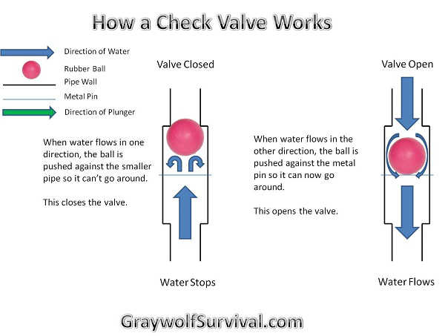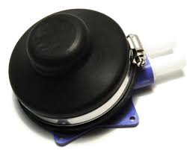

**Marine West squeeze pump fuel primer bulbs were brought to my attention as a starting place for my project. It incorporates two one-way valves to channel water flow in the right direction. Along with this, its rubber bulb can keep its form meaning it will retain its shape, making it perfect for my intention. Lastly its small and compact size makes it the perfect fit for being made into a modular pump.**

**For the casing I will place the pump in, I plan to make it out of aluminum due to its easy shaping as well as its lightweight. I will use short lengths of tubing to connect each module creating a mat like network to transfer the water.**

**Initial Designs:**

**Development designs and development models:**

**Final Designs:**

**Orthographic drawings:**

**Cutting list and parts list:**

**Order of build:**